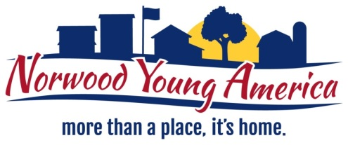
Public Service Technician (PST)
Streets & Parks
Applications being received until 9/17/18.

Full-Time: Hourly position. “Regular Hours” are 7:00am – 3:30pm Monday – Friday. This position does include working a rotating weekend (every 7 weeks, four hour shifts Saturday and Sunday).

Pay Grade/Scale: based on experience and licenses
PST 1 = Pay Grade 9, CDL $17.47 - $21.82
PST 2 = Pay Grade 10, CDL + pool and/or pesticide applicator $18.35 - $22.91
PST 3 = Pay Grade 11, Class C or D Water/Sewer $19.26 - $24.06
PST 4 = Pay Grade 12, Class A or B Water/Sewer $20.23 - $25.26

Biweekly Payperiod: Workweek is Saturday – Friday; paid every other Thursday

Uniforms / Cell Phone: Public Service employees must wear steel-toed boots and high visibility shirt, jacket or vest. Each PST will receive a $150 clothing allowance per year. A City cell phone is provided. Employee can use it for personal use but must follow the Cell Phone Policy.

PTO and Holidays:
- PTO (Paid Time Off) accrued monthly – based on years of service
Less than one year = 8 hours a month
1 year to 5 years = 11 hours a month
6 years to 10 years = 14 hours a month
11+ years = 18 hours a month

- Holidays – the following holidays are observed: New Year’s Day, Martin Luther King Jr Day, Presidents Day, Memorial Day, Independence Day, Labor Day, Veterans Day, Thanksgiving Day, Friday following thanksgiving, Chris Eve, Christmas Day, and one floating holiday.
*If an employee is required to work on a holiday, they are paid time and one-half all hours worked.

Benefits: Begin on 1st day of employment - City pays 85% of the insurance cost; employee pays 15% of the cost

- Health – Health Partners
Deductible $3,600 single, $7,500 family
Premium cost based on age (a copy of the scale may be requested)
Example: Employee and spouse are 45 years old + they have 3 children. Employee Portion per paycheck is: $112.80

- Health Savings Account
Family = $4000, Single = $2000

- Dental – Delta Dental
Single = $42.85
Single + one = $86.10
Family = $117.45

- Other Insurance Available – these benefits are paid 100% by the City
Life, Long Term Disability, Short Term Disability

- PERA – Public Employees Retirement Association (all full-time employees are required to participate in PERA)
City contributes 7.5% of salary
Employee contributes 6.5% salary

