1245.05 Fences

Subd. 1 Building Permit Required. No fence, except temporary fencing, shall be constructed without a building permit. The application shall be accompanied by a plot plan clearly describing the type, location, and method of anchoring the fence.

Subd. 2 Setbacks. Boundary line fences shall be located at least one (1) foot from the property line, except as provided for in Subd. 4 and 5 of this Section. The persons, firms or corporations constructing or causing the construction of such fence shall be responsible for maintaining that part of their property between fence and property line. City staff shall require any applicant for a fence permit to establish the boundary lines of his property by a certificate of survey thereof to be made by any registered land surveyor or by showing the accurate stake markers of the surveyed lot.

Subd. 3 Fencing Conformity. Fencing in all districts shall conform to the following:

- Fences in all districts shall be maintained so that the exposed outer/inner surface shall be uniformly painted or stained in a neat and aesthetically acceptable condition.
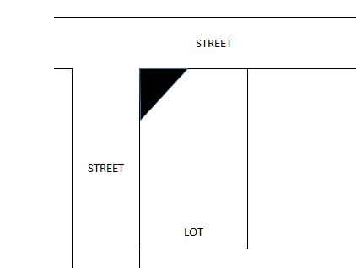
- The side of the fence considered to be the face (finished side as opposed to structural supports) shall face abutting property.
30 feet
30 feet
- No fence shall be permitted on a public right-of-way or boulevard area.
- No fence shall be erected on a corner lot that will obstruct or impede the clear view of an intersection by approaching traffic within a sight triangle defined by measuring thirty (30) feet from intersecting streets .

- All snow-stop fencing may be used from November 1 to April 1. No permit shall be required for temporary fencing.
- All fencing shall be constructed straight, true, and plum
- Fences which are in need of repair or maintenance through type of construction or otherwise, or are otherwise dangerous to the public safety or general welfare and health are considered a public nuisance and the City may commence proceedings for the abatement thereof under Chapter 6, Nuisance Abatement of the City Ordinance. Electric fences may not be used. Material such as chicken, sheep, or hog wire fencing, barbed wire fencing, or snow fencing will not be allowed as permanent fencing, except as stated in paragraph c in this section.
- All fences shall have a gate or opening to allow access from the exterior of the lot.
- All fences shall be constructed of durable materials such as treated or painted wood, cedar, chain link, aluminum, wrought iron, and similar materials intended to be used for fencing in urban areas. Agricultural fences, woven wire, electric wire, plastic, and fences made of flimsy or non-traditional materials/items are prohibited. Barbed wire is prohibited in residential districts but may be allowed on the top of fences in commercial and industrial districts as provided under Subd. 5 “Fencing in Commercial, Business, and Industrial Districts”.

Subd. 4 Fencing in All Residential and Agricultural Districts.

- Setback and design. A fence may be located within the rear yard and side yard to a maximum height of six (6) feet up to the point where it is parallel with the front edge of the building. Fences located in front of a dwelling shall not exceed three and one half feet in height and shall not be placed within two (2) feet of a property line. Fences may be placed in street side corner yards provided the fence is at least fifty (50) percent opaque and not more than four (4) feet in height. A clear sight triangle as defined in Section 1245.05, Subd. 3(D) is required. Fence height shall be measured from grade. within the front yard or side-street yard to the right-of-way shall be ornamental in design and the height of the fence shall not exceed three and one-half (3 ½) feet as measured from grade.
- Fences around dog kennels not exceeding one hundred (100) square feet in size, fences around garden fences will not require building permits but shall adhere to the other regulations of this subdivision.
- All garbage can areas in multi-family developments shall be protected by a privacy fence not less than six (6) feet in height. The privacy fence shall be constructed of wood, vinyl or similar, but shall not include chain link with slats. All gates shall have a self-closing and self-latching latch installed on the outside of the fence.

Subd. 5 Fencing in Commercial, Business and Industrial Districts.

- Business and industrial fences may be erected up to eight (8) feet in height as measured from grade. Fences in excess of eight (8) feet shall require a conditional use permit.
- Business and industrial fences with barbed or razor wire security arms shall be erected a minimum of six (6) feet in height as measured from grade (measured without the security arm) and shall require a Conditional Use Permit. The security arm shall be angled in such a manner that it extends only over the property of the permit holder and does not endanger the public.
- Single-family residential properties located in the Civic (C), Central Business District (CBD), and Commercial/Industrial (C-I) Districts shall conform to the provisions of Subd. 3 of this Section.

